**Q: Inspired by this image, compose a brief interpretive texts that represent different perspectives.**

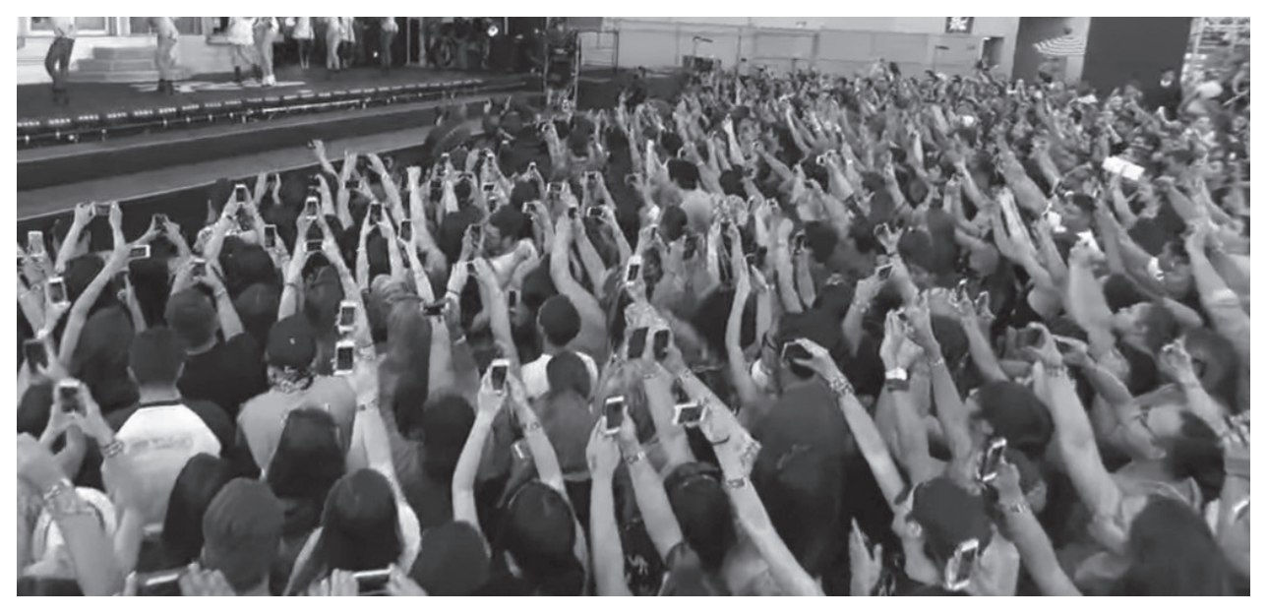

The industrial revolution has brought about many changes to mankind and has dramatically influenced the technological advancement of the species. Innovations such as the phone, computer, vehicles and software have changed our lives in many ways for the better, or arguably, for the worse.

We can’t argue with facts, and the fact is that 66% of the population shows signs of monophobia – the fear of not having contact to a mobile device – and 2 out of every 3 people are addicted to their phone. This is a growing concern that should be brought to attention. Numerous interventions have been undergone to try to reduce this issue, but as long as people are becoming increasingly glued to social media, the exponential curve is unlikely to stop. Other facts include that smartphone and internet addiction can increase loneliness and depression, fuel anxiety, increase stress, exacerbate attention deficit disorders, diminish your ability to concentrate and think deeply or creatively and disturb sleep patterns. This all works to reduce the quality of life and wellbeing of individuals who are addicted to their phones.

However, the technological innovation of the smartphone has created many benefits and convenience due to its design. They provide a method of instant communication, web surfing, capturing moments in life, entertainment, education, GPS, privacy, advertising and many more. The fact is that smartphones have made our lives a lot more convenient, and without them, mankind wouldn’t be the way it is today. Media has greatly influenced our surroundings and in many ways dictate the actions of individuals. With appropriate balance and self-control, smartphones can greatly benefit a person’s life with minimal loss.

Older generations often complain about the younger generations being lazy and glued to their phones, but people’s behaviour is merely a product of surroundings. We’re all living in a constantly changing and advancing world with new technology being introduced to our lives every day, and the significant amount of convenience gained from technology has caused people to feel the need to connect to social media applications.

**Q: Inspired by this image, compose a brief persuasive texts that represent different perspectives.**



Why are people addicted to their phones? This is a question that’s more complex to understand than one may think. We’re all products of our environment, and we’re living in a rapidly changing society with an exponential growth of technological advancement. Things are becoming more convenient than ever before, but with benefit comes a cost, and phone addiction is one of them. The first phone was as large as a brick and was more of a pain to carry around than a benefit. Since then, it’s been developed into a highly convenient device that’s as large as a small notepad. People do and put everything on their phones. Their contacts, social media, GPS and many more are all put into the device, and quite often it’s the only source of communication you have with emergency services. You can imagine why having access to a phone is perceived to be an integral part of safety, but our increasing connectedness to our devices has contributed to various mental disorders such as anxiety and depression. Phone addiction is becoming an increasingly prevalent problem.

When people who are addicted to their phone don’t have access to their phone, they experience unreasonable feelings of anger, tension, depression, irritability and restlessness. This is a clear symptom of phone addiction. Spending excessive amounts of time on a phone causes both tangible losses such as a job or relationship, but also intangible losses such as time (obviously) or self-esteem. This is clearly a reason to stay clear of phone addiction. I mean, who would want to sacrifice those things for unnecessary reasons?

Addiction to social networking, dating apps, texting, and messaging can extend to the point where virtual, online friends become more important than real-life relationships. We’ve all seen the couples sitting together in a restaurant ignoring each other and engaging with their smartphones instead. While the Internet can be a great place to meet new people, reconnect with old friends, or even start romantic relationships, online relationships aren’t a healthy substitute for real-life interactions. Online friendships can be appealing as they tend to exist in a bubble, not subject to the same demands or stresses as messy, real-world relationships. Compulsive use of dating apps can change your focus to short-term hook-ups instead of developing long-term relationships.

Smartphone or Internet addiction can also negatively impact your life by Increasing loneliness and depression, fuelling anxiety, increasing stress, exacerbating attention deficit disorders, diminishing your ability to concentrate and think deeply or creatively, disturbing sleep patterns and encouraging self-absorption. This can lead to harmful behaviours and consequences, taking up your time and energy for something that ultimately won’t have benefit for your future. These are more reasons to avoid steering towards phone addiction.

Simply using your phone won’t lead to these consequences. It’s excessive time on your phone that causes these harmful consequences, so the key is a balance. Most things aren’t harmful in moderation, and phone usage is definitely included. I’m not saying that if you use your phone you’re ruining your lives and future from the inside out. Phones have the potential to save lives and help you avoid making impulsive decisions, but too much is what will cause more harm than good.

We’re living in a world that’s constantly changing, especially in the field of technology. Things are becoming more convenient than ever, but with convenience comes an increasing amount of people who don’t use these innovations wisely and end up developing harmful behaviours. Phone addiction is becoming an increasingly problematic issue that’s affecting people of all ages and ethnic groups. 90% of American adults own a phone. That’s a lot of people, so if we’re aiming for a healthy generation for the 21st century, we need to make sure to use it in moderation.

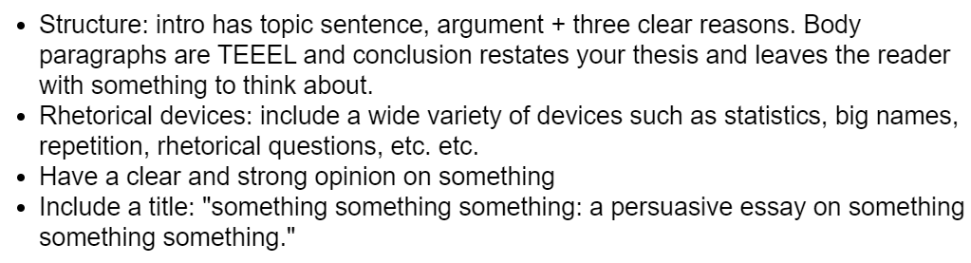

**Phone Addiction in Modern Society – A Persuasive Essay on the Negative Implications of Excessive Phone Usage**

Phone addiction is becoming an increasingly prevalent issue in modern society. We’re all **products** of our environment, and we’re living in a **rapidly changing society** with an **exponential growth** of technological advancement. Because of this, we need to be **careful** as to not fall into compulsive phone usage, but **not all people** see their large quantity of time on their phones as an issue, as they **don’t see its effects** on their physical and mental wellbeing.

People who are addicted to their phone are so connected to it that they feel **unsettled and best** and **violent at worst** when they’re out of reach from it. When people who are addicted to their phone don’t have access to their phone, they experience unreasonable feelings of **anger, tension, depression, irritability and restlessness**. These are clear symptoms of phone addiction and can have **negative implications on your peers** when they interact with you. This is obviously a **reason** to try to stay clear of phone addiction.

Phone addiction can lead to **unnecessary sacrifices**. Spending excessive amounts of time on a phone causes both **tangible losses** such as a job or relationship, as well as **intangible losses** such as time or self-esteem, and addiction to social media can extend to the point where **virtual, online friends** become **more important than real-life relationships**. Online relationships **aren’t a healthy substitute** for real-life interactions. Online friendships can be **detrimental** to your life and is another clear **reason** to avoid phone addiction.

Phone addiction can also negatively affect **mental health**. Phone addiction can negatively impact your life by increasing **loneliness and depression, fuelling anxiety, increasing stress, exacerbating attention deficit disorders, diminishing your ability to concentrate and think deeply or creatively, disturbing sleep patterns and encouraging self-absorption**. This can lead to **harmful behaviours and consequences**, taking up your **time and energy** for something that ultimately **won’t have benefit** for your future. These are **more reasons** to avoid steering towards phone addiction.

**Simply using** your phone won’t lead to these consequences. It’s **excessive time** on your phone that causes these harmful consequences, so the key is a **balance**. Most things aren’t harmful in **moderation**, and phone usage is definitely included. I’m not saying that if you use your phone you’re ruining your lives and future from the **inside out**. Phones have the **potential to save lives** and help you avoid making **impulsive decisions**, but **too much** is what will cause **more harm than good**.

Phone addiction is becoming an increasingly prevalent issue in modern society. It can lead to irritability when out of contact with a phone, unnecessary sacrifices and negative effects on mental health. These are reasons to stay clear of phone addiction. People do and put everything on their phones. Their contacts, social media, GPS and many more are all put into the device, and quite often it’s the only source of communication they have with emergency services. You can imagine why having access to a phone is perceived to be an integral part of safety, but our increasing connectedness to our devices has contributed to various mental disorders such as anxiety and depression as well as compulsive behaviour. It’s up to your self-control to avoid these implications.